

Artificial Intelligence and Robotics

Interactive Graphics: final project

Paintball Arena Zombie Edition

Iacopo Mezzanotte: 1964256

Valerio Lorenti: 1816544

Sommario

ABSTRACT 3

Code foundamentals and main libraries 3

Architecture 3

Main 3

Index.html 3

PersonFarm 3

Monitors 4

Administrators 4

Environment 4

Map 4

Player 5

Enemies 5

Map interactions 5

Weapons 6

Pistol 6

MP5 6

Minigun 6

In-Game User Interactions 7

Pre-Match User Interactions 7

Time of the Day 7

Arena Lights 8

Difficulty 8

God Mode 8

Sound Effects 8

# ABSTRACT

Have you ever noticed that regardless of the scenario the zombies are slow and unarmed? The game developed is a First Person Shooter setted in an arena, but instead of two teams, the player is alone against a zombie horde. To keep the environment the least violent possible everyone use paintball guns. The player can move and shot using the traditional commands (WASD and the mouse).

# Code fundamentals and main libraries

The code is mainly in JavaScript, html and CSS. Every game dynamics is done through the JavaScript files while the home page, settings, and game over page in done through an HTML file with some css.

The main libraries used are:

* THREE.js: it is a JavaScript library use to create 3D contents on web based on WebGL,
* CANNON.js: it is a physical engine for 3D graphics in JavaScript,
* TWEEN.js: it is a JavaScript library that enable to create smooth animations,

Each object or entity in the scene can be a THREE object or CANNON object or both. The main practice to add a new object in the game is to generate its shape as a THREE object and give him a physical body with CANNON. If the object has to be animate, TWEEN is used to create and attach the animation.

# Architecture

The application contains different files in order to keep the responsibilities separated and to avoid a monolithic structure. In particular the system has monitor files, administrator files and others three files.

## Main

This is the central files. In the Main file is resent the Main administrator which contains every static information (the ones that don’t change during the game), so it communicates with the settings menu of the game. here it is defined also the function that generate the map (so also the generation of all the entities) and the load model function.

## Index.html

It is responsible of the first user interface. It manages, also the interaction between the player and the different menus and settings. One of the main functions is to manage the setting changes by the user and send them to the JavaScript files.

## PersonFarm

Inside this file there is the definition of the player’s and enemies’ structures and animations as also the settings of the weapons (as the fire rate for example).

## Monitors

There are three different types of monitors, one for each fundamental aspect of the game:

* AIMonitor: it is addicted to the definition of the mechanics of enemies’ movements. In particular the movements of the enemies is based on player position, they depend also on the fact if they are hit by a bullet from the player: at the beginning the zombies start in a state of resting but, if the player come next to them or shot them they begin to move in the direction of the player and arrived at a certain distance they begin to shot the player and move around him to make the aim more difficult.
* InputMonitor: it the responsible of the decoding the inputs by the keyboard and mouse in game actions.
* PersonMonitor: it is the monitor of each player possible action and admitted state. In this file there is the definition of the reloading and shot methods.

## Administrators

* BulletAdministrator: it is the main actor of the bullets behaviour, it define the parameters of bullets as the color and dimension,
* EntityAdministrator: it is the file that define every entity inside the game, in fact every entity has its parameters, but with a common base.
* ScoreAdministrator: it manages all the dynamic statistic as the number of lives or the mount of enemies still alive during the game. These parameters are updated during the game by the score administrator and displayed thanks to the ScoreAdministrator,

# Environment

The environment includes: the map, enemy entities and the player. To build the map also some 3D models are used and the map changes at each new match. After the generation of the map there is the spawn of enemies (in random positions) and the spawn of the player (in the middle of the map). The environment also includes a skybox. The user can choose the types of skybox before the beginning of the game; in particular it can choose among a morning, evening or night timing.

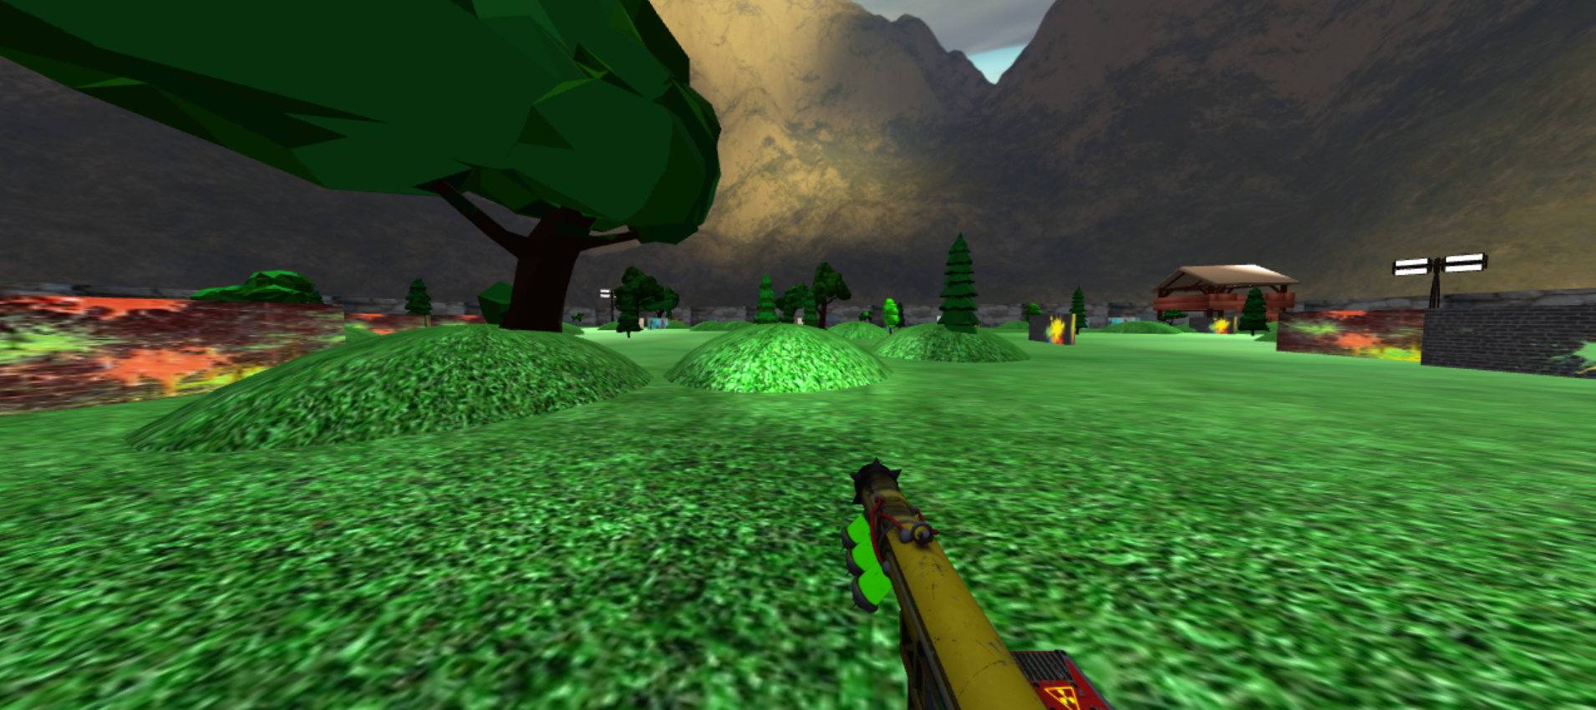

## Map

As said before it is generated at each match thanks to an homemade Algorithm. For each new object to place in the map the possible randomly generated position is compared to the position of the objects already present in the map, if the possible position is next to one of the already present object the placing is skipped. The algorithm admits some overlapping between objects. In the generated world there are three different types of geometries:

* Walls: a parallelogram with attached a texture of a spotted brick wall,
* Hills: created by a sphere placed under the ground with a attached a grass texture,
* Trees: they are 3D models loaded thanks to GLTF.Load(). These models don’t have a physical body so it is attached to them in a second moment after their placing. The choice among the type of tree is done randomly.
* SpotLights: four 3D model of a spotlight at the four corners of the map are placed in the generated world, the user can choose before the start to turn on or turn of these spotlitghs.

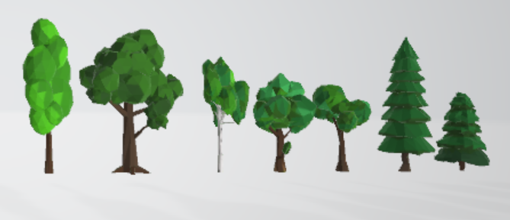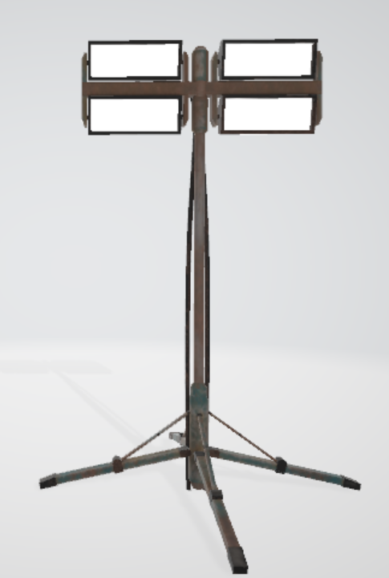

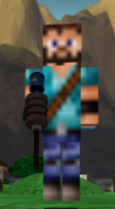

## Player

It is an hierarchical structure of a human: two legs, a torso, two arms and the head. It has a texture attached and a walking animation. On his right arm the player holds the weapon, the initial weapon is fixed and the user can change it during the game with other two types of weapons (the weapons are described in the following pages). To the main character are attached also three types of cameras: first person camera, zoomed camera and third person camera, also in this case the player begins always with the same type of camera and then during the game he can change the vision.

## Immagine che contiene erba Descrizione generata automaticamenteEnemies

During the game is possible to meet two different types of enemies:

* the Small Zombie with a small amount of lives and a simple texture
* the Giant Zombie one with a large amount of lives and a more complex texture.

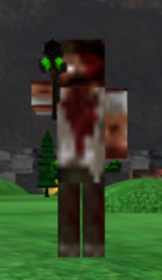Every enemy has his weapon which is chosen randomly. Both the enemies are sensitive to the player actions (shot) and position. In particular if the player is inside a determined range the enemy automatically starts to attach him as also if the player is far enough to not attach player if the player shot him the shotted enemy starts to move in the player position. The number of enemies can be choose by the user and there is an balanced switching between the two different enemies. The enemies have two animations: the walking (an animation that give the impression of a rapid walk) and the death (after some hit the enemy collapses to the floor and then despawn).

## Map interactions

There is a particular zone in the map. The shelter is an homemade structure made by using THREE, CANNON and also an imported model of a roof. In the shelter the player can recover a significant amount of lives once per game. The recovering is done by dynamically check the player position: in detail, if the player reaches the shelter and jump over the aid box (an imported 3D model in the middle of the floor of the shelter) placed inside the shelter he recovers five lives.

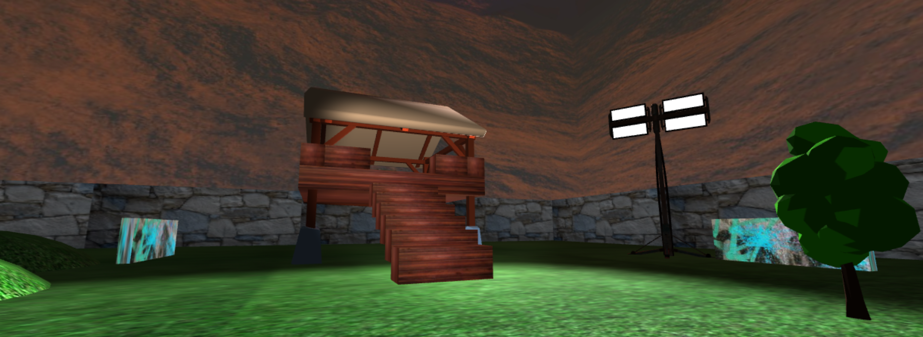

# Weapons

Both player and enemies have the opportunity to take advantage of three types of weapons. These weapons are 3D imported models, and every weapon has its own parameters. The player can, during the game, change weapon instead the enemies have a random fixed weapon among the possibles three.

## Pistol

It is the weakest weapon (low bullet velocity, mass and range) with the lowest ammo and firing rate, but its time of reloading is the shortest.

## MP5

It is the most versatile weapon, it has a quite good ammo, firing rate, and range with an acceptable reloading time.

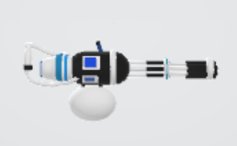

## Minigun

From a ballistic point of view it is the stronger weapon but it has a very high time of reloading.

# In-Game User Interactions



During the game the player interface includes some informations as: remaining lives and enemies, available ammo and time. The user can interacts during the match in several way via mouse and keyboard:

* The user can shot (left click of the mouse) and change (tab on the keyboard) weapons, every time he switches weapon or he goes out of ammos the game automatically recharge the weapons, but the user can choose to reload the weapon via keyboard (r button),
* The user can change the camera point of view (z button). There are three possible choice: first person, zoomed and third person.
* The user can interact with one spotlight placed in way to seem a torch attached to the weapon. Pressing the “t” button on the keyboard the user can turn on or turn of the spotlight.
* There are also the classical commands: WASD to move in the four directions and SPACE to jump and press SHIFT to run.

In case of recharging and recovering lives thanks to the shelter the game will warn the player with a sound track and with a po-up message in the bottom of the display.



# Pre-Match User Interactions

The user can decide before a match several settings thanks to the and the home page (buttons and sliders).

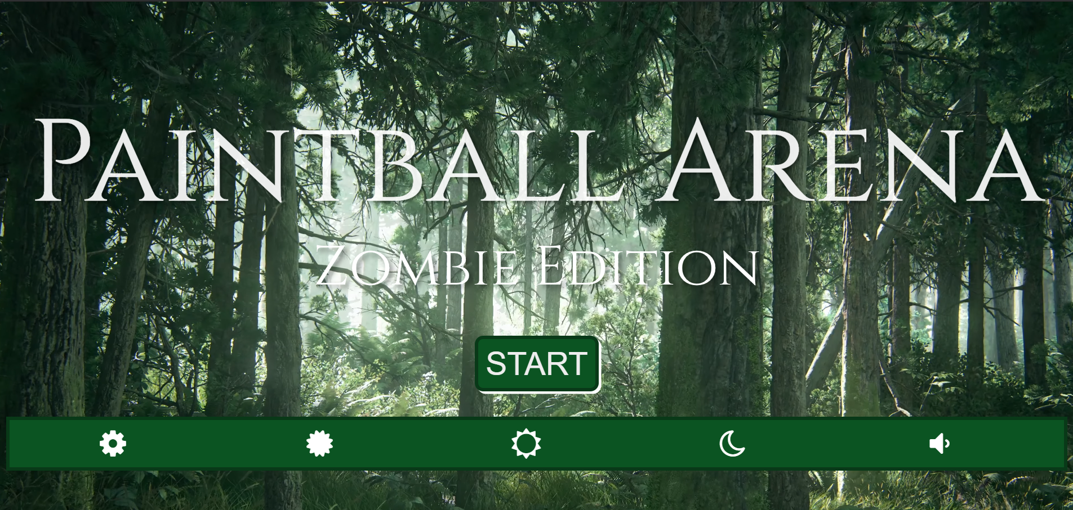

## Time of the Day

The user can choose the time of the day where the match is going to be played. This choice will influence the skybox, light colour, direction and intensity. There are three possible day times:

* Day: in this case there is a skybox of a morning panorama with a strong directional light placed at the noon with white colour.
* Evening: for the evening the skybox of a sunset is used. The directional light is placed on the side of the skybox to give the effect of a low sun, also the intensity of the light is lower compared to the one of the noon and the colour tend to red.
* 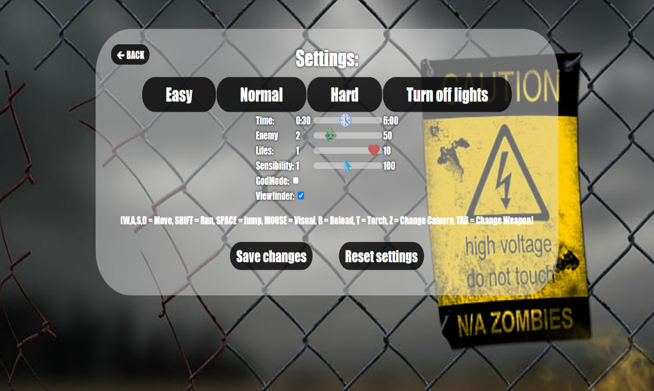Night: in the night selection the skybox is very dark and suggestive, the directional light is very week in such way to copy the moon.

## Arena Lights

The user can turn on and turn off the four big spotlights in the corners of the arena. There are four different strong white spotlight in the corners of the map that aim in the centre of the arena. These lights are independent from the ambient and directional light setted in the time of the day selection.

## Difficulty

The player can change the difficulty before the game this choice will influence the amount of enemies, lives, and time. The user can also change independently from the difficulty the following parameters: lives amount, number of enemies, sensibility, duration of the match, and he can decide to show or not the viewfinder. In order to make the game a little bit more difficult in the last minute of the match every enemy is able to see and follow the player from any position of the map.

## God Mode

The user can decide to activate the god mode. In the god mode the player doesn’t suffer damage and he kills every enemy with one hit. It has been designed to leave greater freedom of exploration and play to the user.

# Sound Effects

The game has also a main soundtrack. It is audible in the menu by pressing the audio button, during the game the music is stopped. During the match the user can listen different sound effects like:

* Hit by an enemy,
* Death of an enemy,
* Shot from the player,
* Jump sound,
* Recharge and change weapon effect,
* Recover file lives in the shelter effect,
* Victory soundtrack,
* Lose soundtrack.